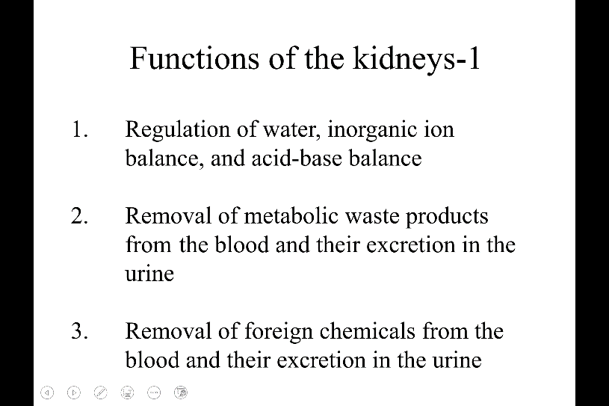
Anatomy of the kidney

Function of the kidney
- Urine making, by this what they achieve?
- Water, inorganic ions (Na+, K+…) ,acid base balance.
- Remove waste product from the blood, and excrete the waste in the urine. This is important, need to be eliminate, or can be intoxicated by the waste product.
- Removal foreign chemical and excrete to the urine (ex: antibiotics, when infection happen and transcribed the antibiotic. the color of urine changed, with smell. This is because the excrete of antibiotic metabolite to the urine. This allow to maintain the healthy concentration )

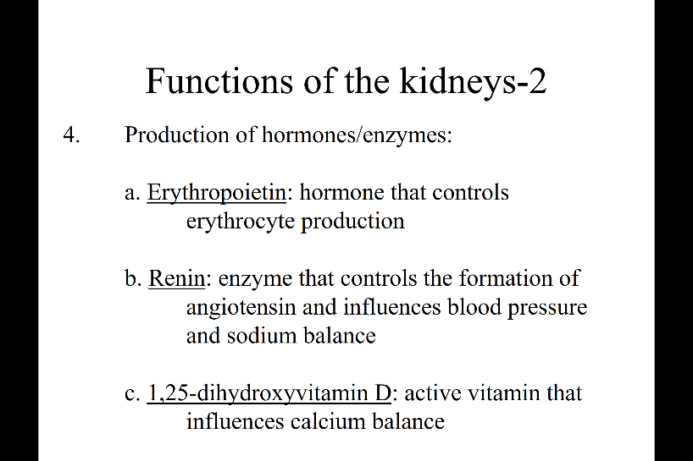
Endocrine type of function
- Produce hormone/ enzyme
- Erythropoietin(hormone) control the RBC production.
- Renin(enzyme) to control the angiotensin which have the regulation of blood pressure and the sodium balance.
- 1,25 hydroxyvitamin D. The active form of vitamin D. Vitamin is activated by the kidney.

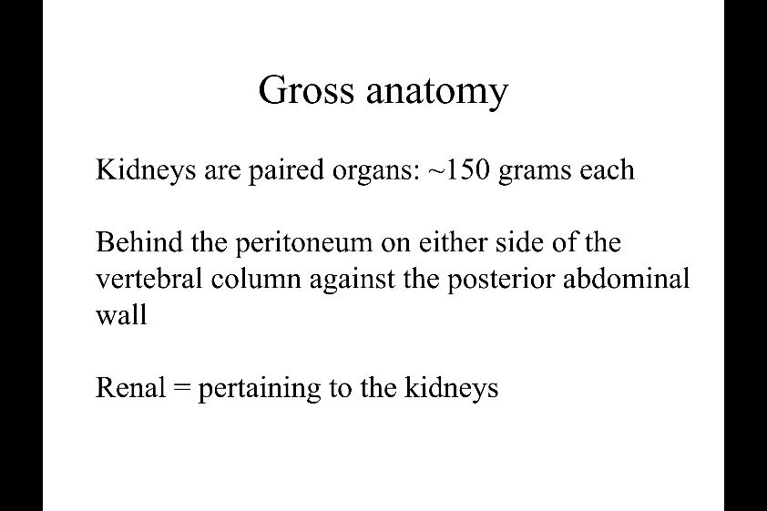

Gross Anatomy
- Paired organ (~150 gram each), normally ppl are born with two kidney.
- (in the back) Located the peritoneum, against the posterior abdominal wall. (this means on both side of the backbone)
- Renal
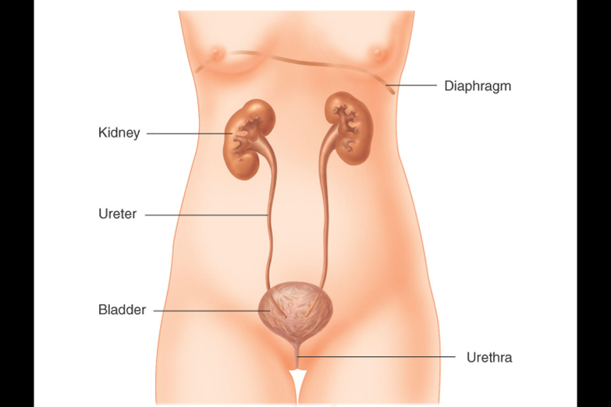
this is how kidney look
- 2 kidney
- Its very close to the back
- Kidney is connected to the bladder by a tube called ureter
- Bladder lead to the outside wall through urethra.

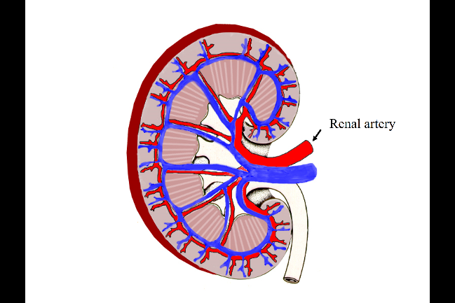
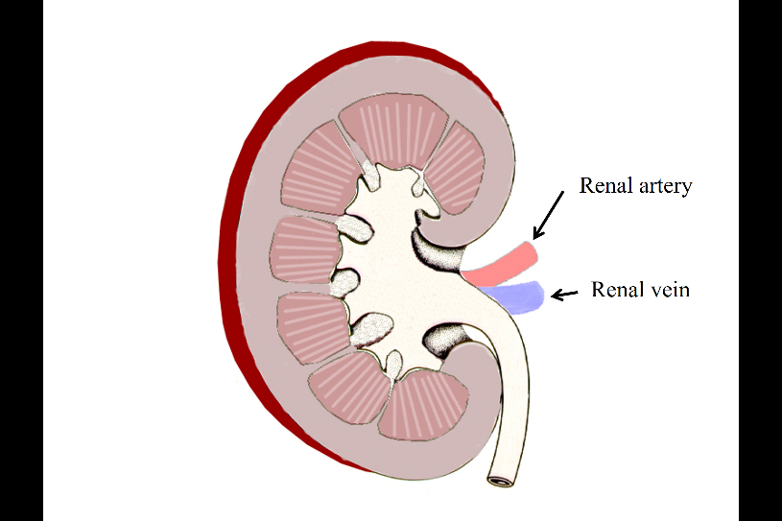
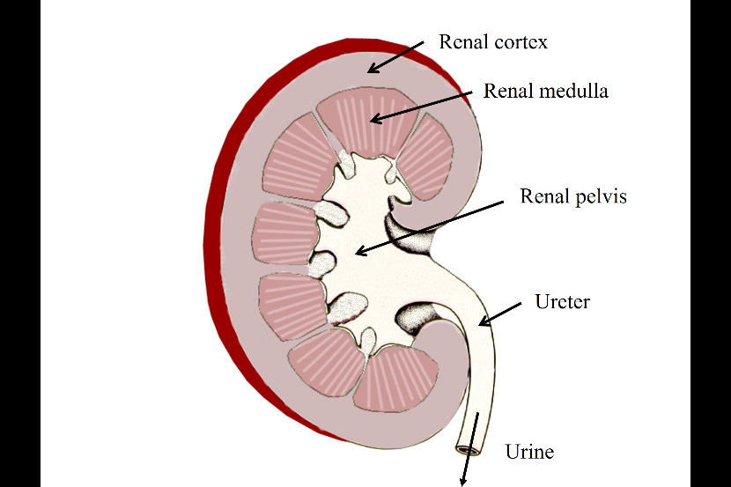
The longitudinal section of the kidney
- Different color tone
- Outside: renal cortex
- Inside: renal medulla
- Spacing side is the renal pelvis
- The renal cortex, and medulla make renal pelvis. Then through the ureter go into the bladder
- The vasculature: renal artery feeds to the kidney, renal vein drain from the kidney – adrenal gland.

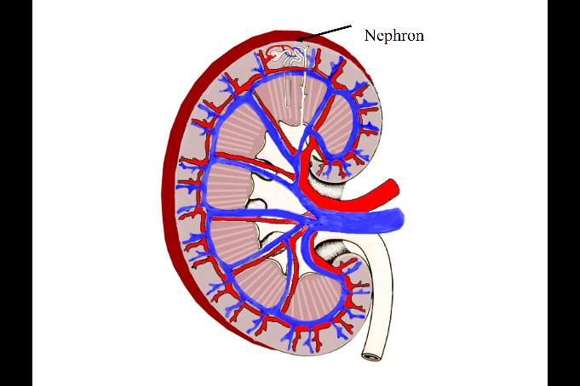
- Once the blood comes in to the renal artery, the artery branch out to go through the kidney. The blood comes into the kidney and goes to the medulla (trigonal structure called: medulla pyramid) the renal artery run between medulla pyramid, called interlobar kidney (between the lobes)
- As soon as the medulla reach the junction between cortex and medulla. Change the direction by 90 degrees, run up the border of the cortex in medulla, look like an arch, form the arcuate artery
- Branch out again by 90 degrees, go through the surface of the kidney: called the interlobular artery.
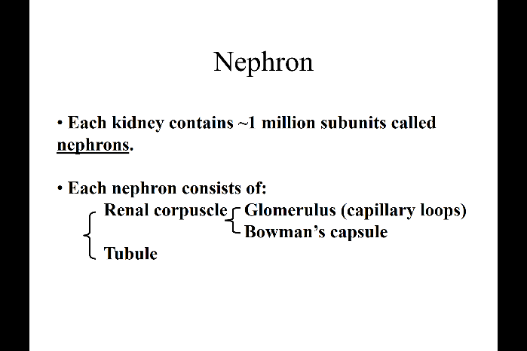
- Finally the interlobular artery formed an important structure called afferent arterial which feed the functional structure “Nephron”
The venus system: runs side by side with the arterial system, go through medulla pyramid….. eventually to the vein.
Nephron: the functional unit of the kidney. The kidney make up of nephron and blood system.
- Each kidney contains 1 million nephrons (know it.)
- two portions : Renal corpuscle and tubule
- Renal corpuscle is made of glomerulus (tangled capillary loops) surround by bowman’s capsule.
- The renal corpuscle will transfer to the tubule.
The important structure:
- The top: cortex, the bottom: medulla. This enter the central space of the kidney (renal pelvis)

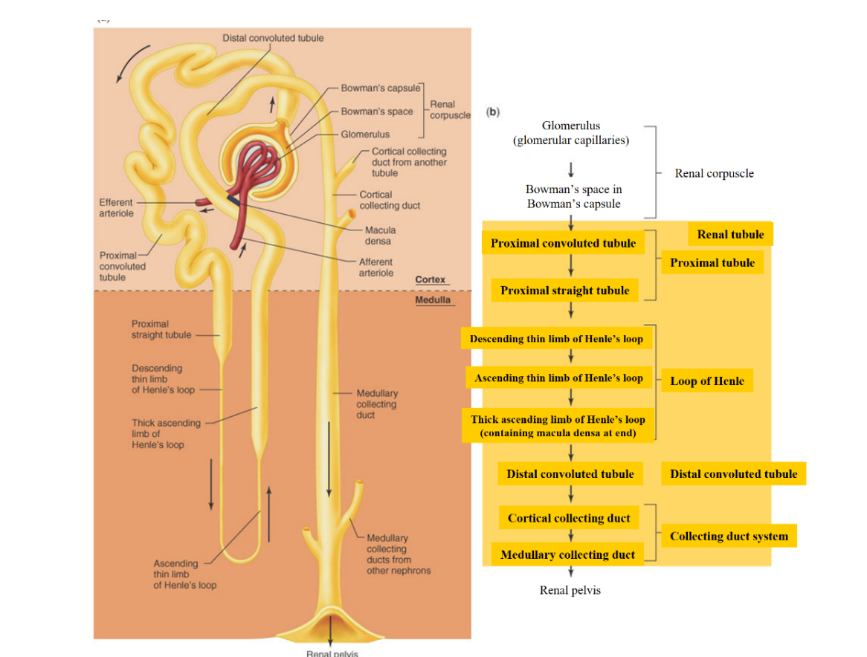
- Ball like structure is Renal corpuscle capillary loop (glomerulus). afferent arterial comes in. This afferent arterial is branch out form the renal artery in the vascular system.
- Another important is renal corpuscle is in the cortex, never in the medulla. This is where the urine start
- The tubing(tubular ---- goes into the medulla come back out of the medulla back cortex, and always touches upon the originating renal corpuscle other branches merge, thicken open up to the renal pelvis.
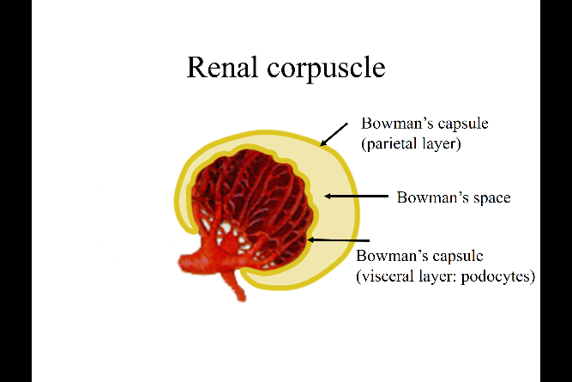
The entire system is hollo space surround by the epithelial cell (called tubule)
Renal corpuscle
- Ball like structure, the (capillary) glomerulus in the bowman’s capsule (single layer of the epithelial cell)
- Because of the structure, epithelial cell is divided into 2 parts.
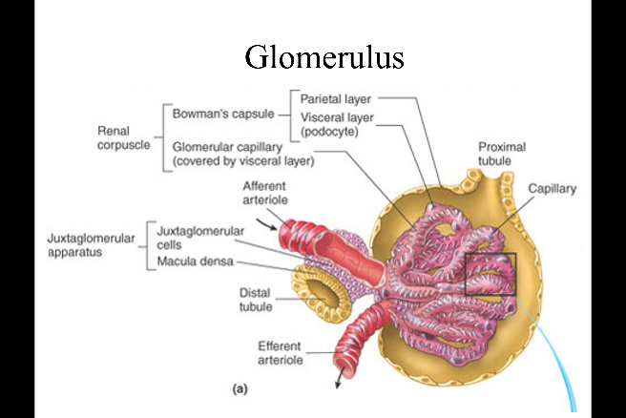
- Parietal layers
- Visceral layer is the epithelial directly attach to the glomerulus, also called podocyte here.
- The space between the two layers is the bowman’s space.
- The entire structure called renal corpuscle, can also be refer as glomerulus as entire structure.
The drawing of the glomerulus
- Afferent (in) and efferent arterial (out)

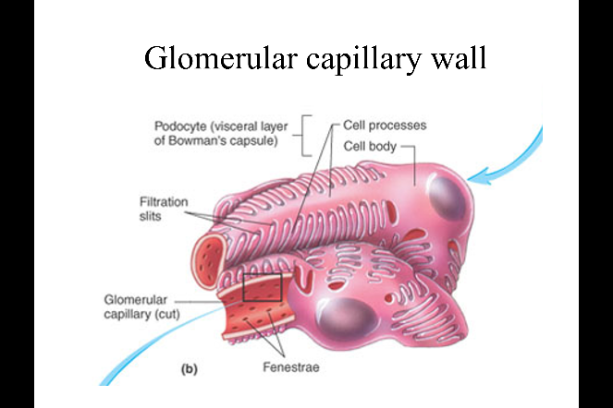
The visceral layer of glomerular epithelial cell
- Podocyte (feet like, tightly surround)
Ecm
- These structure are food process connected by the filtration slits.
- The middle basement membrane
- Along the capillary is the endothelial cell.
- Holes in the endothelial cell, called fenestra meaning there is window.
- The way urine is made:
- The blood from capillary filtration occur through the fenestra of the endothelia cell through the basement membrane in-between the foot processes through the filtration slit.--> in to the bowman’s space.
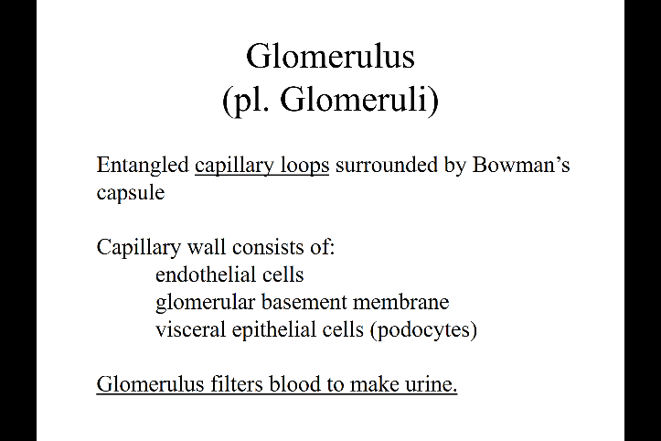
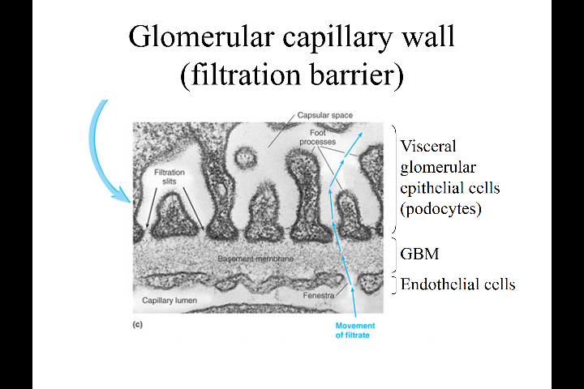
- The 3 layers: podocyte, GBM, endothelial cell regulate what should pass. Filter the blood.

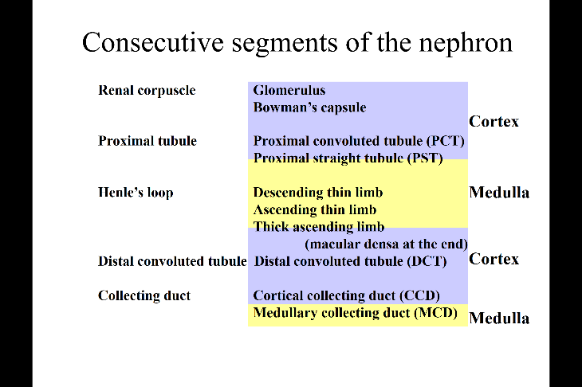
Nephron – know where and the names
- Proximal tubule, start in the cortex, and goes down in the medulla
- Henle’s loop
- 1st go deep in the medulla, called the deseeding limb
- Turns around, become ascending. Initially thin but than become thick ascending limb
- The end of thick ascending comes out the medulla and attaches the originating renal corpuscle.
- After attaching, it change to Distal convoluted tubule in the cortex.
- Finally Collecting duct goes down the medulla toward the renal pelvis – cortical collecting duct (in the cortex), medullary collecting duct (in the medulla)
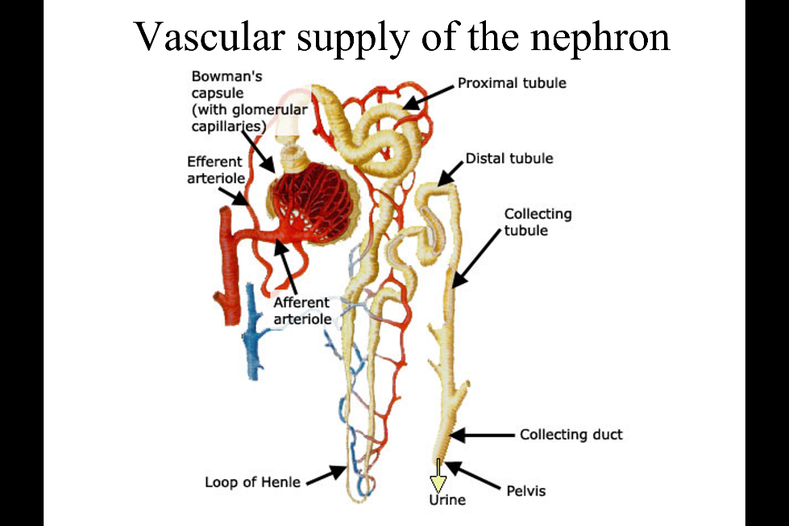
Nephron is mostly epithelial cell and need blood supply.
- The blood supply is the afferent arterial.
- Afferent become glomerulus leave glomerulus, called efferent arterial branch out o2 and nutrient supply to the nephron tubular cell. (This branch out called peritubular capillaries), The blood vessel also go down to the medulla as well.
- After giving a lot of oxygen and nutrient. Take back the waste product and come back become venues, and go the venues system.
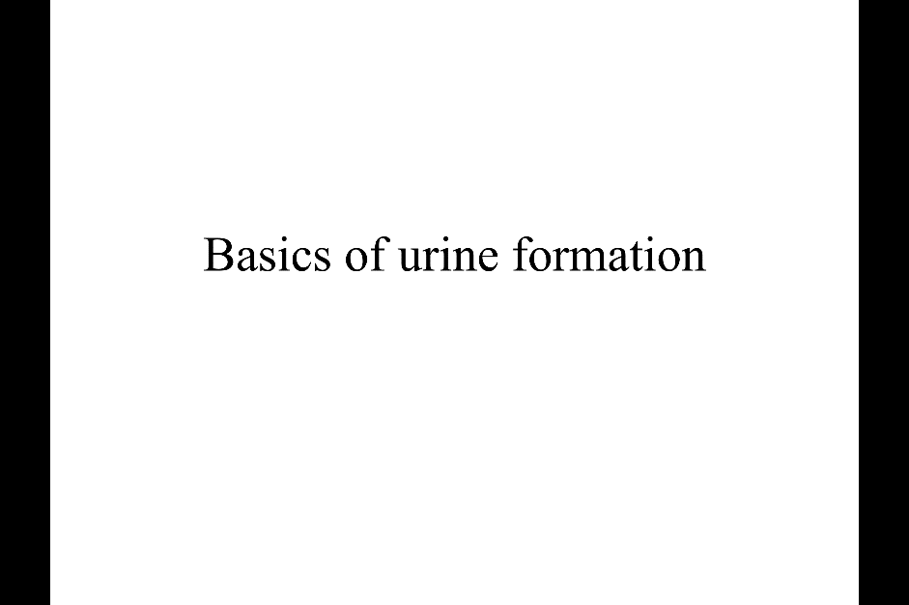

3 important step in the urine formation
- Glomerular filtration
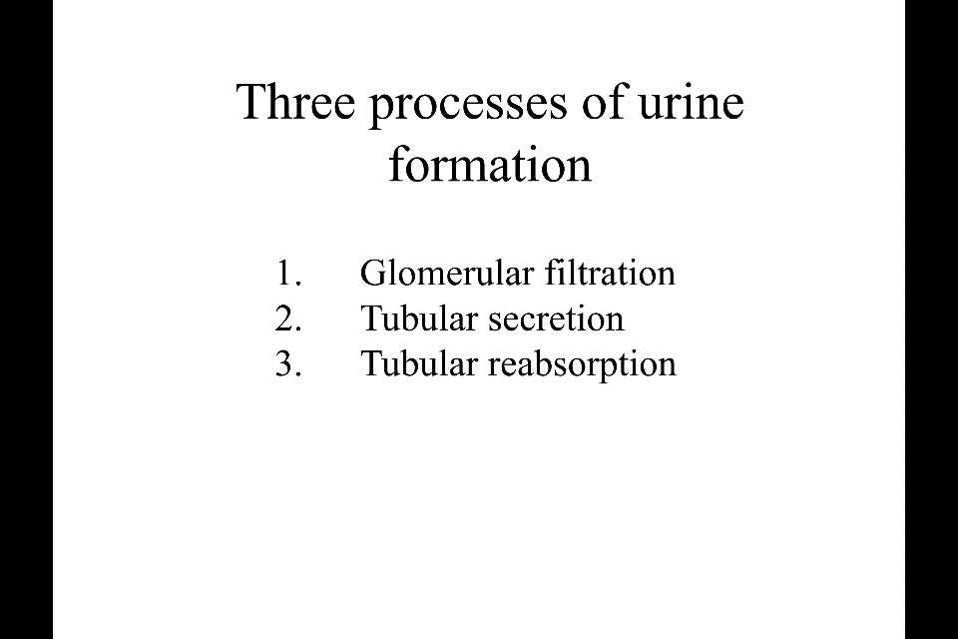
- Tubular secretion+ reabsorption

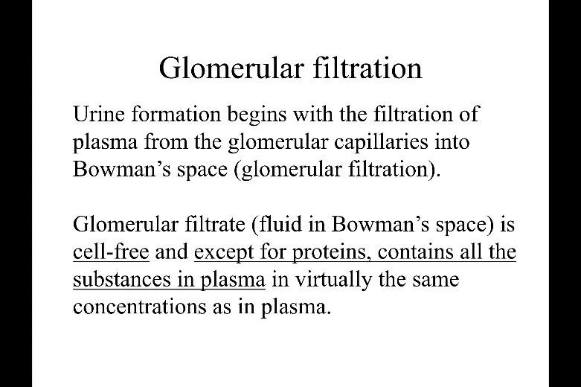
Glomerular filtration filtrate the blood or plasma into the bowman’s space.
- The fluid get filtrated is cell free, with small molecules but no protein (the contents are very similar to the plasma, but cell free and no big protein )

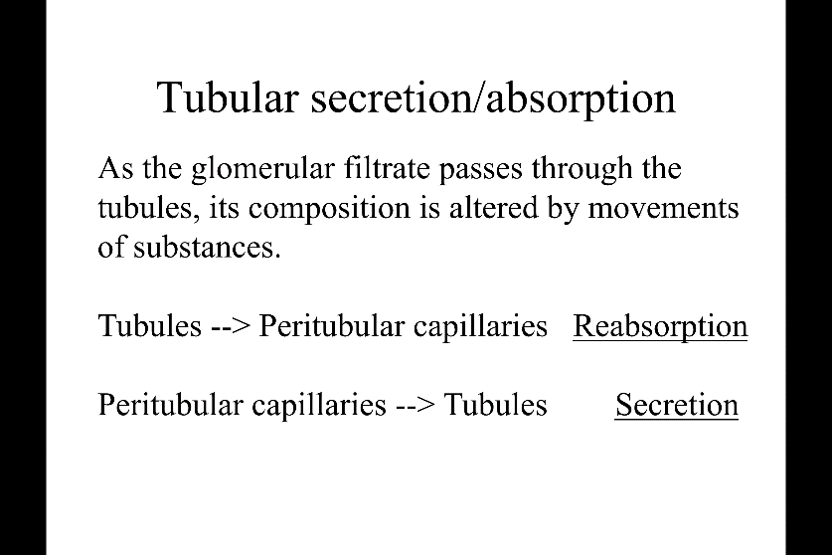
- Tubular secretion and absorption
- the reabsorption: movement of the substance from tubular lumen to the peritubular capillaries (the filters go back to peritubular capillaries which means systemic circulation, going back to the body)
- the secretion is from peritubular capillaries into the tubular

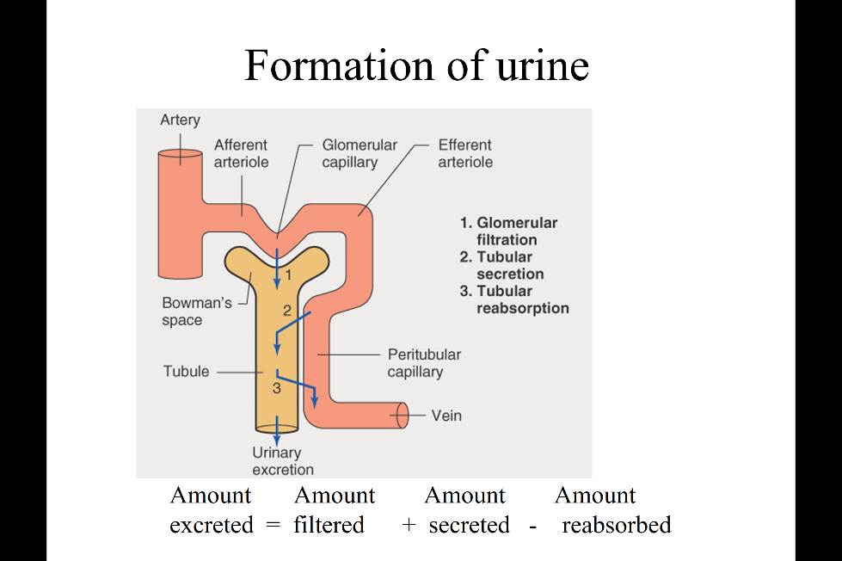
formation of the urine
- the first step is the filtration at the glomerulus
- certain substances move from peritubular capillaries into the tubular lumen (secretion)
- some of the substance back from the tubular lumen to the peritubular capillary (reabsorption)
- the final amount: the amount filtered (at the glomerulus) + the amount secreted(to the tubular lumen) – the reabsorb (go back)
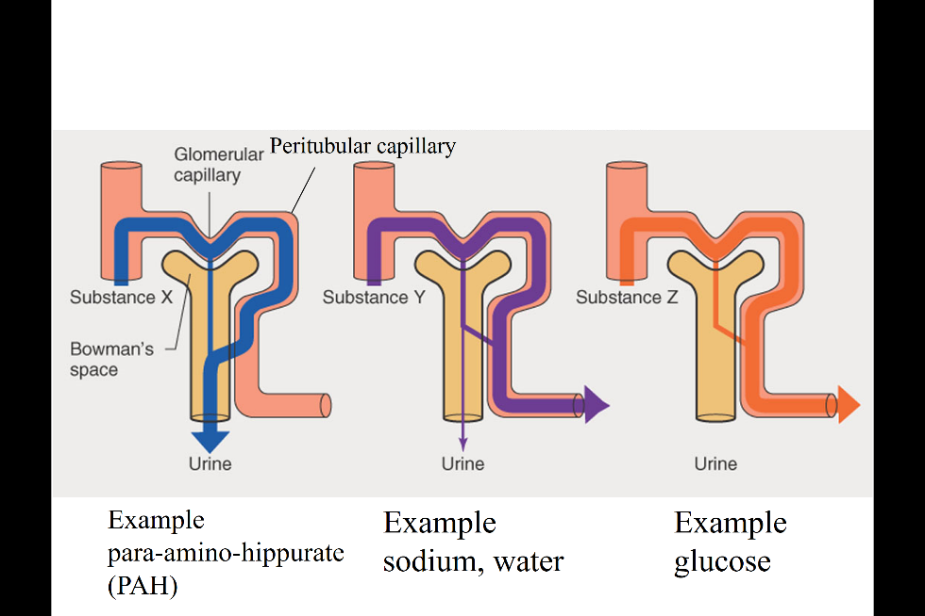
- remember: excretion vs secretion: excretion is the final elimination to the urine , secretion is the movement from peritubular capillary into the lumen.
3 example of different behavior
- the substance is filtered at the glomerulus (X,Y,Z ) but after that the behavior is quite different.
- X: what is left in peritubular capillary is entirely secreted to the tubular (at the end everything get to the lumen, all get eliminated-----ex: para-amino-Hippurate, this is used to test the renal function long time before)
- Y: what was filter is there but a lot of reabsorb to the peritubular capillary (many substance ----- ex: sodium, water)
- Z: free refilter but entirely reabsorb( important small molecule, ex: amino acid, glucose)
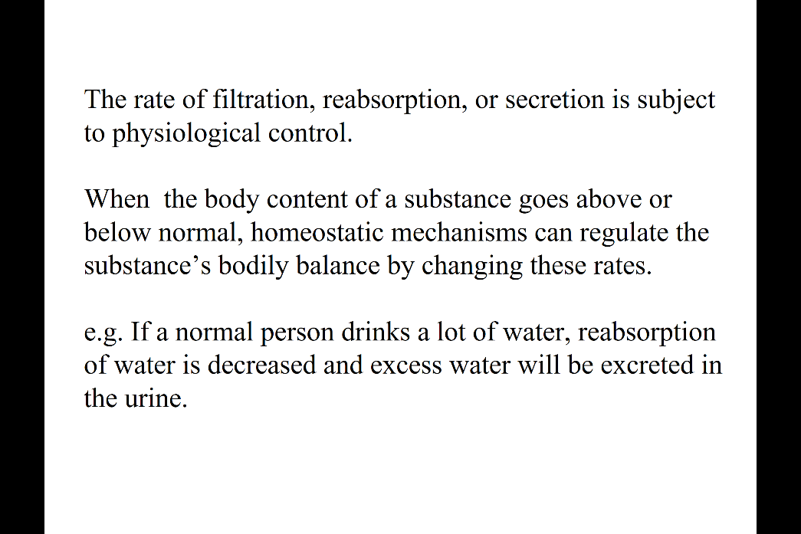
- steps of urine formation, some are regulated some aren’t.
- The general rule is that regulation happen to maintain homeostasis: ex: water intake, kidney adjust the amount of urine. This is due to kidney adjust the reabsorption of water depends on amount of intake.
- also salt, potassium….

